
CSA15 – CLOUD COMPUTING AND BIG DATA ANALYTICS

ASSIGNMENT 1 – CO1

Design, Analyse and Validate a Virtualized Cloud Infrastructure for Efficient Resource Allocation and Data Centre Management.

CO1: Apply cloud computing technologies including hardware–software evolution, virtualization, web services, and service models to develop cloud-based solutions.

Field | Details | Field | Details
Student Name | Yazhini R | Register Number | 192521190
Department / Section | Btech IT | Academic Year / Semester | 2nd year
Faculty Name | Dr.Arul Raj A.M | Nature of Assignment | Individual
Duration | 1 Week | Total Marks | 50
Submission Date | 05-11-2026 | Evaluation Date

MARK SHEET (Rubric-based evaluation)

Task | Title | Max | Awarded | Evidence / evaluation focus
1 | Existing Data Centre and Requirements | 3 |  | Definition; characteristics; deployment models; scenario mapping
2 | Virtualization Fundamentals and Hypervisors | 3 |  | Timeline; hardware evolution; relevance to university
3 | Server Consolidation and Resource Calculations | 3 |  | Web/software evolution; SOA; APIs; scenario relevance
4 | Virtual Machines and Containers | 5 |  | Hypervisor types; VM/container comparison; consolidation; limitations
5 | Virtualized Storage and Network Infrastructure | 4 |  | SOA and SOAP/REST; three university APIs; request/response examples
6 | Resource Allocation, Scheduling and Monitoring | 5 |  | Responsibility layers; five-application mapping; comparison; providers
7 | Availability, Security and Disaster Recovery | 3 |  | Four or more variants; two justified choices; provider risks
8 | Virtualized Cloud Data Centre Architecture | 5 |  | Labelled diagram; deployment/service models; scaling; security; DR
9 | Hands-on Implementation and Validation | 4 |  | Running VM/container; PaaS/SaaS; tests; actual screenshots
10 | Cost, Performance and Final Recommendation | 7 |  | Three-way comparison; 3-year costs; risks; phased roadmap
11 | Day-4 Design Challenge | 8 |  | Impact; evaluation; adaptation; evidence-based defence
 | TOTAL | 50 |  | Percentage :

EVIDENCE VERIFICATION CHECKLIST

Tasks | Evidence expected | Status (✓ / P / ✗) | Evaluator note
1–3 | Conceptual explanations, comparisons and relevant illustrations |  | Explanations and relevant scenario mapping documented
4 | Virtualization calculations with stated assumptions and peak-load caution |  | Calculations present; practical capacity validation recommended
5–7 | API examples, service responsibility table and justified XaaS choices |  | Required conceptual evidence documented
8 | Labelled architecture diagram, caption below figure and component justification |  | Architecture documented; sizing assumptions need testing
9 | Actual code, environment details, execution logs, API outputs and screenshots |  | Procedures provided; actual execution evidence not established
10 | Cost assumptions, 3-year totals, risk controls and migration roadmap |  | Estimates and rationale documented
11 | Day-4 changes, 10× load strategy, 99.9% target and 40-college isolation |  | Design analysis documented; practical validation pending

IMPLEMENTATION EVIDENCE CHAIN

Evidence item | Status | Observation
Source code |  | Flask REST API and Dockerfile provided in the proposed implementation
Virtualization |  | Docker container configuration documented; running-container evidence required
PaaS or SaaS |  | Managed web-service deployment procedure described; live deployment not verified
Functional test |  | Expected HTTP 200 response and JSON output documented; actual output required
Failure case |  | HTTP 404 test case documented; actual execution record required
Screenshots |  | Screenshot requirements identified; authentic screenshots need verification
Reproducibility |  | Build commands, run commands, endpoints and expected results specified

MANDATORY SUBMISSION EVIDENCE CHECK
✓ = Present in documented answer; P = Partly present; ✗ = Missing / not satisfied
Task | Evidence expected | Status | Evaluator note
1 | Cloud definition, characteristics, deployment models and scenario mapping |  | All conceptual requirements covered
2 | Evolution timeline, hardware development and university relevance |  | Well explained with relevant examples
3 | Internet software evolution, SOA and APIs |  | Clear explanation and scenario relevance
4 | Hypervisors, VM/container comparison and consolidation calculations |  | Calculations included; peak-load limitations discussed
5 | SOAP/REST comparison and three university APIs |  | API methods and request/response examples documented
6 | IaaS/PaaS/SaaS responsibility layers and application mapping |  | All five applications categorized with justification
7 | XaaS variants and two justified selections |  | Six variants explained; DBaaS and DRaaS recommended
8 | Labelled architecture, scaling, security and disaster recovery |  | Design and component justifications documented
9 | Working container, PaaS/SaaS deployment, actual tests and screenshots |  | Code and procedures provided; actual execution evidence requires verification
10 | Three-year cost comparison, risks and migration roadmap |  | Cost assumptions, calculations and recommendations included
11 | Impact analysis, 10× load, 99.9% availability and tenant isolation |  | Changed requirements evaluated; load-test evidence recommended

IMPLEMENTATION EVIDENCE CHAIN
Evidence item | Status | Observation
Source code |  | Python Flask REST API and Dockerfile documented
Virtualization |  | Docker build and run procedures provided; execution screenshot required
PaaS or SaaS |  | Cloud deployment steps described; actual deployment confirmation required
Functional test |  | HTTP 200 and expected JSON response documented; actual test output required
Failure case |  | HTTP 404 test case included; execution evidence required
Screenshots |  | Required screenshots identified but authenticity and completeness not verified
Reproducibility |  | Installation, configuration, commands and testing steps documented
Interpretation |  | Technical outcomes and implementation limitations explained
Code and report consistency |  | Proposed API, Docker configuration and testing procedure are aligned

SUBMISSION CHECKLIST (Not Separately Marked)
Requirement | Status
All 11 tasks answered | ☐ Yes ☐ Partly ☐ No
☐ Existing data-centre requirements and limitations are identified. | ☐Yes ☐ Partly ☐ No
☐ Virtualization and hypervisor types are explained. | ☐Yes ☐ Partly ☐ No
☐ Server consolidation calculations include working and assumptions. | ☐Yes ☐ Partly ☐ No
☐ VM and container comparison and workload mapping are included. | ☐Yes ☐ Partly ☐ No
☐ Storage and network virtualization are addressed. | ☐ Yes ☐Partly ☐ No
☐ Resource allocation and monitoring policies are included. | ☐Yes ☐ Partly ☐ No
☐ Security risks, backup and disaster recovery are discussed. | ☐Yes ☐ Partly ☐ No
☐ A labelled virtualized data-centre architecture diagram is included. | ☐ Yes ☐Partly ☐ No
☐ Implementation screenshots and actual test evidence are provided. | ☐ Yes ☐ Partly ☐ No
☐ Three-year cost analysis and migration roadmap are included. | ☐ Yes ☐ Partly ☐ No
GENERAL INSTRUCTIONS
• Use clear headings and answer each task in the order given.
• Include diagrams, tables, calculations and screenshots wherever requested.
• State assumptions and units for all numerical calculations.
• Use credible technical references and cite sources consistently.
• Ensure that implementation evidence reflects work actually performed by the team.
• Submit the report as a well-formatted document with a title page, contents, references and appendices where required.

OVERALL REMARKS

_______________  Student Signature | _______________  Faculty Signature | _______________  Program Director

CSA15 – Cloud Computing and Big Data Analytics
ASSIGNMENT 1
CO1: Apply cloud computing technologies including hardware–software evolution, virtualization, web services, and service models to develop cloud-based solutions.

Assignment Title:
Design, Analyse and Validate a Virtualized Cloud Infrastructure for Efficient Resource Allocation and Data Centre Management
(Total Marks – 50) Duration: 1 week
--------------------------------------------------------------------------------------------------------------
Scenario – University Data Centre Virtualization
A growing university operates an on-premises data centre that hosts its Student Information System, Learning Management System, Library Management System, Examination Portal, research applications and institutional website. Each major application runs on a separate physical server. Server resources are underutilized during normal periods, while admission, examination and result-publication periods create high demand. The university experiences rising electricity and maintenance costs, slow hardware procurement, limited scalability and inadequate disaster-recovery arrangements.
The current data-centre environment is assumed to have the following characteristics:
• 20 physical servers, each with 16 CPU cores, 64 GB RAM and 2 TB local storage.
• Average CPU utilisation is approximately 20%; peak utilisation reaches 90–95% during admission and examination periods.
• Most servers are dedicated to individual applications and cannot share unused capacity efficiently.
• There is no centralized virtual-machine (VM) management platform and no tested live-migration process.
• Backup is performed periodically, but a separate disaster-recovery site and documented recovery objectives are not available.
• The university wants to reduce infrastructure costs while improving availability, scalability, security and resource utilization.
You are appointed as a cloud infrastructure consultant. Analyse the existing environment and design a virtualized cloud data-centre solution. Your proposal must explain the role of hypervisors, virtual machines, containers, storage and networking virtualization, resource allocation, monitoring, security and disaster recovery. Justify all major decisions using calculations, diagrams and practical evidence.
Design Challenge:
On Day 4, the university announces that it will introduce a new digital learning platform and extend selected services to 10 affiliated colleges. The expected peak workload will increase to five times the current peak. The university requires at least 99.9% service availability, stronger tenant isolation and controlled operating costs. Re-evaluate your original design and decide whether it should be retained, modified or redesigned..
TASK 1 – Analyse the Existing Data Centre and Identify Requirements (3 Marks)
Study the current data-centre environment and identify the reasons for adopting virtualization.
Explain the purpose of a data centre and identify its major components: compute, storage, networking, power, cooling and management.
Identify at least four limitations of the existing physical-server environment.
Define resource utilization, server consolidation, scalability, availability and fault tolerance.
Prepare a requirement table covering performance, capacity, security, availability and cost.
Evidence Expected: A concise assessment of the existing environment, clearly linking each identified problem to a virtualization or cloud-infrastructure requirement.
TASK 2 – Explain Virtualization Fundamentals and Hypervisors (4 Marks)
Explain the technologies that enable multiple computing environments to share physical infrastructure.
Define virtualization and explain its purpose in a cloud data centre.
Explain the role and working of a hypervisor.
Differentiate Type-1 (bare-metal) and Type-2 (hosted) hypervisors with suitable examples such as VMware ESXi, Microsoft Hyper-V, KVM and Oracle VirtualBox.
Compare full virtualization, para-virtualization, hardware-assisted virtualization and OS-level virtualization (containers).
Recommend a suitable hypervisor for the university and justify the selection.
Evidence Expected: A labelled virtualization architecture diagram, comparison table and justified hypervisor recommendation.
TASK 3 – Design Server Consolidation and Calculate Resource Requirements (5 Marks)
Propose a consolidation plan to reduce the number of physical servers while maintaining sufficient capacity.
Explain physical-to-virtual (P2V) migration and server consolidation.
Estimate the total CPU and memory demand using the stated server specifications and average utilization. State all assumptions.
Assume a target average CPU utilization of 65% on the consolidated hosts. Calculate the minimum number of hosts required based on CPU capacity, then check whether memory capacity changes the result.
Include a reasonable capacity reserve for peak demand and host failure; show the calculation clearly.
Discuss resource overcommitment, CPU scheduling, memory ballooning and the noisy-neighbour problem.
Evidence Expected: Worked calculations showing CPU and memory requirements, assumptions, capacity reserve and the recommended number of physical hosts. A final number without working will not receive full credit.
TASK 4 – Compare Virtual Machines and Containers (4 Marks)
Determine which workloads should run in virtual machines and which can run in containers.
Explain the architecture and characteristics of virtual machines and containers.
Compare VM and container isolation, operating-system requirements, startup time, resource overhead, portability and management.
Map at least five university workloads (for example, database, legacy student system, web portal, learning platform and analytics service) to VMs or containers.
Explain how Docker and a container orchestration platform such as Kubernetes can support deployment and scaling.
Identify situations where a VM is more appropriate than a container.
Evidence Expected: A VM-versus-container comparison and a workload mapping table supported by technical justification.
TASK 5 – Design Virtualized Storage and Network Infrastructure (4 Marks)
Design storage and network resources that support the proposed virtualized data centre.
Explain storage virtualization and compare direct-attached storage (DAS), network-attached storage (NAS) and storage area networks (SAN).
Explain software-defined storage (SDS), thin provisioning, snapshots, replication and backup.
Explain network virtualization, virtual switches, VLANs, virtual networks and software-defined networking (SDN).
Propose separate logical network segments for administration, student services, databases and management traffic.
Recommend suitable storage and network approaches for performance, security and availability.
Evidence Expected: A labelled storage and network design with explanations of the selected technologies and their roles.
TASK 6 – Plan Resource Allocation, Scheduling and Monitoring (5 Marks)
Develop a resource-management strategy that allocates infrastructure capacity efficiently.
Explain CPU, memory, storage and network resource allocation to VMs and containers.
Compare static allocation and dynamic allocation, including resource reservations, limits and shares.
Explain load balancing, workload scheduling, auto-scaling and high availability.
Identify suitable performance indicators: CPU utilization, memory utilization, disk I/O, network throughput, latency and VM availability.
Propose monitoring and alerting methods, and explain how the administrator should respond to resource contention.
Evidence Expected: A resource-allocation policy table and a monitoring plan that includes measurable indicators, thresholds and corrective actions.
TASK 7 – Evaluate Data Centre Availability, Security and Disaster Recovery (4 Marks)
Identify the risks associated with a virtualized data centre and propose suitable controls.
Explain hypervisor security, VM isolation, secure VM images, patch management and privileged access control.
Discuss VM escape, VM-to-VM attacks, insecure snapshots, VM sprawl and denial-of-service risks.
Recommend network segmentation, encryption, multi-factor authentication, role-based access control and audit logging.
Explain backup, replication, snapshots, live migration and disaster recovery.
Define Recovery Time Objective (RTO) and Recovery Point Objective (RPO), and propose suitable targets for at least two university applications.
Evidence Expected: A risk-and-mitigation table and a disaster-recovery plan with justified RTO and RPO values.
TASK 8 – Create the Virtualized Cloud Data Centre Architecture (5 Marks)
Construct an end-to-end architecture integrating compute, storage, network, virtualization and management components.
Draw a labelled architecture showing users, internet or campus network, firewall, load balancer, physical hosts, hypervisor layer, VMs/containers, virtual network, storage and monitoring.
Show how the university applications are distributed across hosts and how shared resources are allocated.
Include a management plane for provisioning, monitoring, logging and policy enforcement.
Show backup or replication to a secondary site or cloud region.
Justify the architecture in terms of scalability, performance, fault tolerance, security and cost.
Evidence Expected: A complete, clearly labelled architecture diagram and a written justification for each major component and design decision.
TASK 9 – Hands-on Implementation and Validation (5 Marks)
Build a small proof-of-concept that demonstrates virtualization and resource management.
Create at least one VM using VirtualBox, VMware, Hyper-V or KVM, or create a container using Docker.
Deploy a simple university-related service, such as a web page, student-record API or database-backed application.
Configure CPU, memory and storage resources and record the selected values.
Perform functional tests and at least one resource or load test. Record the observations.
Capture screenshots of the VM/container configuration, running service, resource-monitoring output and test results.
Document installation steps, commands, configuration details, issues faced and how they were resolved.
Evidence Expected: Reproducible implementation steps, source/configuration files, annotated screenshots and actual test evidence. Do not present simulated results as actual execution.
TASK 10 – Evaluate Cost, Performance and Final Recommendation (3 Marks)
Evaluate the proposed solution against the existing physical data-centre arrangement.
Compare the current physical-server model and proposed virtualized model in terms of hardware cost, electricity, cooling, maintenance, licensing and administration effort.
Prepare a simple three-year cost comparison using clearly stated assumptions. Separate one-time capital expenditure from recurring operational expenditure.
Evaluate expected improvements in utilization, scalability, availability and manageability.
Identify risks such as licensing costs, vendor lock-in, skills requirements, hardware failure and migration downtime.
Provide a phased migration roadmap, identifying which applications should be migrated first and why.
Evidence Expected: A three-year cost table, risk analysis, migration roadmap and evidence-based final recommendation.
DAY-4 DESIGN CHALLENGE
TASK 11 – Re-evaluate and Adapt the Virtualized Infrastructure (8 Marks)
Changed Requirement
The university introduces a digital learning platform and extends selected services to 10 affiliated colleges. The expected peak workload increases to five times the current peak. The system must achieve 99.9% availability, provide secure isolation between colleges and remain within a limited operating budget.
Re-evaluate your original design. You may RETAIN, MODIFY or REDESIGN the proposed infrastructure.
Impact Analysis – 2 Marks
Identify changes in workload, users, storage, network traffic and availability requirements.
Explain how multi-tenant access affects VM/container isolation, network segmentation and access control.
Identify which original capacity and cost assumptions are no longer valid.
Capacity and Availability Evaluation – 2 Marks
Estimate the additional CPU, memory, storage and network capacity needed for the five-times peak workload.
Evaluate whether the proposed number of hosts and the existing failover arrangement are sufficient.
Explain the meaning of 99.9% availability (approximately 8.76 hours of downtime per year) and identify measures needed to approach it.
Adaptation or Redesign – 2 Marks
Decide whether to retain, modify or redesign the original infrastructure and justify the decision.
Describe the revised architecture. Consider clustering, live migration, auto-scaling, container orchestration, multi-zone deployment or hybrid-cloud capacity where appropriate.
Explain changes to resource-allocation policies, tenant isolation, backup and disaster recovery.
Evidence-Based Defence – 2 Marks
Support the revised design with capacity calculations and clearly stated assumptions.
Compare the cost and operational complexity of the original and revised designs.
Discuss trade-offs involving performance, availability, security, licensing and management effort.
Evidence Expected: A technically justified decision supported by revised architecture, capacity calculations, availability considerations, security controls and cost comparison.
.Re-evaluate your original design in response to these changed conditions. You may:
RETAIN → MODIFY → or REDESIGN
your original solution.
Impact Analysis – 2 Marks
Discuss:
- What has changed from the original problem
- Which original assumptions (load, users, availability, cost) are affected
- Why the web services and APIs now become critical
- How multi-tenant access by 40 colleges affects security and isolation
Evidence Expected: A clear analysis of how the changed requirements affect the original cloud design.
Evaluation of the Original Design – 2 Marks
Discuss:
- Whether the chosen service models and virtualization plan can handle a 10x load
- Whether auto-scaling and the single-region deployment are sufficient for 99.9% availability (about 8.76 hours of downtime allowed per year)
- Whether cost remains acceptable under the new load
- Whether another service model or XaaS offering would give better overall results
Evidence Expected: A technically supported evaluation of the original design under the new conditions.
Adaptation or Redesign – 2 Marks
Discuss:
- Decide whether to retain, modify or redesign the solution
- Describe the revised architecture (for example API gateway, container orchestration, serverless components, multi-zone deployment or a hybrid model)
- Explain what changed in the service model mix and in the virtualization approach
- If you retain the original design, give sufficient technical justification for why no change is required
Evidence Expected: An appropriate design response to the changed requirement, with clear technical reasoning.
Evidence-Based Defence – 2 Marks
Discuss:
- Capacity and availability calculations
- Cost comparison between the original and the revised design
- Security and multi-tenancy considerations
- Trade-offs such as vendor lock-in, complexity and migration effort
Evidence Expected: A well-supported final decision that follows logically from the analysis.
MARK DISTRIBUTION
Task | Title | Bloom's Level | Marks
Task 1 | Existing Data Centre and Requirements | L2 – Understand / Analyse | 3
Task 2 | Virtualization Fundamentals and Hypervisors | L2 – Understand | 3
Task 3 | Server Consolidation and Resource Calculations | L3 – Apply | 3
Task 4 | Virtual Machines and Containers | L4 – Analyse | 5
Task 5 | Virtualized Storage and Network Infrastructure | L3/L4 – Apply / Analyse | 4
Task 6 | Resource Allocation, Scheduling and Monitoring | L4 – Analyse | 5
Task 7 | Availability, Security and Disaster Recovery | L4 – Analyse | 3
Task 8 | Virtualized Cloud Data Centre Architecture | L6 – Create | 5
Task 9 | Hands-on Implementation and Validation | L3 – Apply | 4
Task 10 | Cost, Performance and Final Recommendation | L5 – Evaluate | 7
 | Subtotal

Task 11 | Day-4 Design Challenge | L4/L5/L6 – Analyse / Evaluate / Create | 8
 | TOTAL |  | 50

TASK 1 – ANALYSE THE EXISTING DATA CENTRE AND IDENTIFY REQUIREMENTS

1.1 Purpose and Components of a Data Centre
A data centre is a centralized facility that houses the computing, storage and networking equipment used to store, process, manage and deliver an organization’s applications and data. The university data centre supports the Student Information System (SIS), Learning Management System (LMS), Library Management System, Examination Portal, research applications and institutional website.
Component | Purpose in the university
Compute | Physical servers and processors run the university’s applications and databases.
Storage | Disks and storage systems hold student records, examination data, documents and backups.
Networking | Switches, routers and firewalls connect users, servers, campus networks and the internet.
Power | UPS units, power distribution units and generators ensure a continuous electrical supply.
Cooling | Air-conditioning and precision cooling systems prevent servers from overheating.
Management | Monitoring, configuration, access-control, backup and administration tools are used to operate the facility.

1.2 Limitations of the Existing Environment
Existing problem | Effect | Virtualization requirement
Low average CPU utilization (20%) | Most of the installed server capacity remains idle. | Consolidate workloads onto shared hosts.
Peak CPU utilization of 90–95% | Applications may slow down during admission and examination periods. | Apply resource scheduling, reservations and elastic capacity.
One application per physical server | Unused capacity cannot be shared between applications. | Run multiple isolated VMs on common physical hosts.
High electricity and cooling cost | A larger number of physical servers increases power and cooling consumption. | Reduce the number of physical machines wherever capacity permits.
Slow hardware procurement | New applications take a long time to deploy. | Provision VMs and containers quickly from templates.
No centralized VM management or tested migration | Maintenance work and failures disrupt services. | Adopt centralized management, clustering and live migration.
No separate tested disaster-recovery site | Data and services may remain unavailable after a major failure. | Implement backups, replication and a documented DR plan.

1.3 Important Definitions
Resource utilization: The percentage of available CPU, memory, storage or network capacity that is in use at a given time.
Server consolidation: The use of virtualization to combine workloads from several underutilized physical servers onto fewer, more powerful hosts.
Scalability: The ability of a system to increase or decrease its resources in line with workload demand.
Availability: The percentage of time for which a service is operational and accessible to users.
Fault tolerance: The ability of a system to keep operating, with little or no interruption, when one of its components fails.

1.4 Requirement Table
Requirement | University need | Proposed solution
Performance | Fast access during admission, examination and result periods. | Load balancing, CPU scheduling, SSD storage and continuous monitoring.
Capacity | Support for current applications and the future digital learning platform. | Pooled compute, memory and storage with room for expansion.
Security | Protection of student, staff and examination data. | Network segmentation, encryption, MFA and role-based access control.
Availability | Continuous operation of critical portals. | Host clustering, redundant networking, backups and DR replication.
Cost | Lower power, cooling and maintenance expenses. | Server consolidation, automation and controlled cloud bursting.

Conclusion:
The current environment suffers from low resource utilization, high operating costs and inadequate recovery arrangements. A virtualized infrastructure is therefore required to pool resources, improve utilization, deploy applications faster and strengthen availability and disaster recovery.

TASK 2 – EXPLAIN VIRTUALIZATION FUNDAMENTALS AND HYPERVISORS (3 MARKS)

2.1 Definition and Purpose
Virtualization is the process of creating virtual versions of computing resources such as servers, operating systems, storage and networks. It allows multiple isolated virtual machines (VMs) to share a single physical server. In a cloud data centre, virtualization improves hardware utilization, flexibility, scalability, isolation and centralized management.

2.2 Role and Working of a Hypervisor
A hypervisor, also called a Virtual Machine Monitor (VMM), is software or firmware that creates and manages virtual machines. It allocates CPU, memory, storage and network resources to each VM, keeps the VMs isolated from one another and controls their access to the physical hardware.
Physical server hardware (CPU, RAM, disk, network)
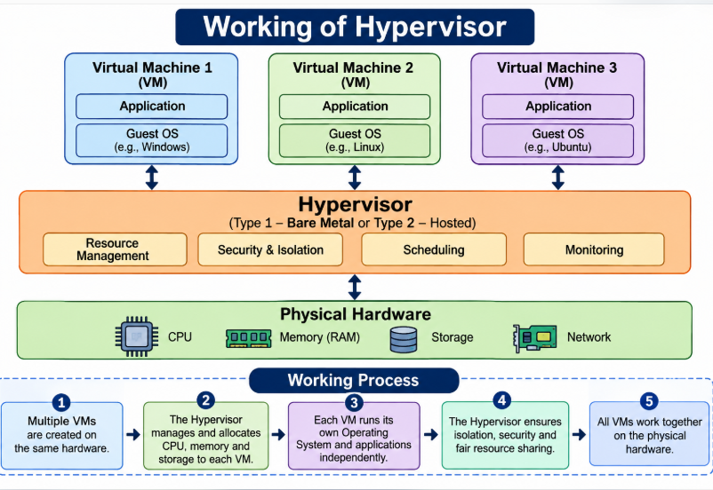

2.3 Type-1 and Type-2 Hypervisors
Feature | Type-1 (Bare-metal) | Type-2 (Hosted)
Installation | Runs directly on the physical hardware. | Runs as an application on a host operating system.
Performance | Usually higher, because there are fewer software layers. | Lower, because of the additional host-OS overhead.
Use | Enterprise servers and production data centres. | Learning, testing and desktop virtualization.
Examples | VMware ESXi, Microsoft Hyper-V, KVM. | Oracle VirtualBox, VMware Workstation.

Recommended choice: A Type-1 hypervisor, such as VMware ESXi or a properly managed KVM-based platform, is suitable for the university’s production data centre. It provides efficient hardware access, centralized management, strong VM isolation and support for clustering and live migration. Oracle VirtualBox is suitable for the student proof of concept but not as the main production platform.

2.4 Virtualization Techniques
Technique | Meaning | Example / use
Full virtualization | The hypervisor presents virtual hardware so that an unmodified guest OS can run. | Running Windows or Linux as a VM.
Para-virtualization | The guest OS is aware of the virtualization layer and cooperates with the hypervisor through optimized interfaces. | Optimized virtual I/O drivers (for example, virtio) and paravirtualized devices.
Hardware-assisted virtualization | CPU features such as Intel VT-x or AMD-V allow guest operating systems to run efficiently. | Used in modern server virtualization.
OS-level virtualization | Multiple isolated containers share the host OS kernel. | Docker containers for web services.

Conclusion: Virtualization allows the university to run several isolated workloads on shared physical infrastructure. A Type-1 hypervisor is recommended for production, while Type-2 software can be used for laboratory demonstrations.

TASK 3 – DESIGN SERVER CONSOLIDATION AND CALCULATE RESOURCE REQUIREMENTS (3 MARKS)

3.1 P2V Migration and Server Consolidation
Physical-to-Virtual (P2V) migration converts an existing physical server, including its operating system, applications and data, into a virtual machine. Server consolidation then places multiple migrated VMs on a smaller pool of physical hosts. Before migration, compatibility, application dependencies, storage, network settings and backups must be checked.

3.2 Existing Resource Calculation
Given: 20 servers; each has 16 CPU cores, 64 GB RAM and 2 TB storage.
Total CPU capacity = 20 × 16 = 320 CPU cores
Average CPU demand = 320 × 20% = 64 cores
Peak CPU demand (using 95%) = 320 × 95% = 304 cores
Total physical memory = 20 × 64 = 1,280 GB
Assumed average memory use = 1,280 × 60% = 768 GB
Total local storage = 20 × 2 = 40 TB

3.3 Host Requirement at 65% Target Average CPU Utilization
Assume that each proposed host has 32 CPU cores and 512 GB RAM. At a target CPU utilization of 65%, one host supports 32 × 0.65 = 20.8 cores of planned CPU demand.
CPU hosts for average demand = 64 / 20.8 = 3.08
Round up = 4 hosts (without failure reserve)
For N+1 host failure protection, 4 hosts are not sufficient:
3 surviving hosts × 32 × 0.65 = 62.4 cores < 64 cores.
5 hosts: after one host fails, 4 × 32 × 0.65 = 83.2 cores.
Therefore, 5 hosts meet average demand with one-host failure reserve.
Memory check: Five hosts provide 5 × 512 = 2,560 GB. After one host fails, the remaining four provide 4 × 512 = 2,048 GB, which is well above the assumed average memory demand of 768 GB. CPU is therefore the limiting resource for average-load planning.

3.4 Peak-Demand Capacity Check
Peak CPU demand = 304 cores
Required host count at 65% target = 304 / (32 × 0.65)
= 304 / 20.8 = 14.62
Round up = 15 hosts without N+1 reserve.
With one host failure: 16 hosts are required.
After one failure: 15 × 32 × 0.65 = 312 cores,
which is greater than 304 cores.
Recommended planning: Five hosts can support the calculated average demand with one-host failure protection, but they cannot support the stated 90–95% peak demand. If all of the existing peak demand must be handled on-premises at the 65% planning target, the university should plan for 16 hosts, subject to workload measurement and budget approval. A practical phased design can begin with a smaller cluster and add hosts before peak periods, using cloud bursting only after it has been tested.

3.5 Resource Management Concepts
Resource overcommitment: Assigning more virtual CPU or memory than the physical capacity provides, on the expectation that all VMs will not use their maximum at the same time. Excessive overcommitment can degrade performance.
CPU scheduling: The hypervisor shares processor time among VMs according to shares, reservations, limits and workload priority.
Memory ballooning: A balloon driver inside the guest OS, controlled by the hypervisor, reclaims unused memory from a VM when the host is short of memory. Reclamation should be monitored because excessive ballooning can degrade performance.
Noisy-neighbour problem: One VM or tenant consumes excessive shared resources and reduces the performance of other VMs. Resource limits, reservations and monitoring help to control it.
Conclusion: Resource calculations must consider both average and peak demand. Under the stated assumptions, a five-host cluster is adequate for average CPU demand with N+1 protection, whereas sixteen 32-core hosts are needed to meet the calculated current peak at a 65% target with one host failure.

TASK 4 – COMPARE VIRTUAL MACHINES AND CONTAINERS (5 MARKS)

4.1 Virtual Machine Architecture
A virtual machine is a software-based computer with virtual CPU, memory, disk and network interfaces. Each VM runs its own guest operating system on top of a hypervisor. VMs provide strong separation between operating-system environments and are useful for legacy applications and applications that need a different OS.

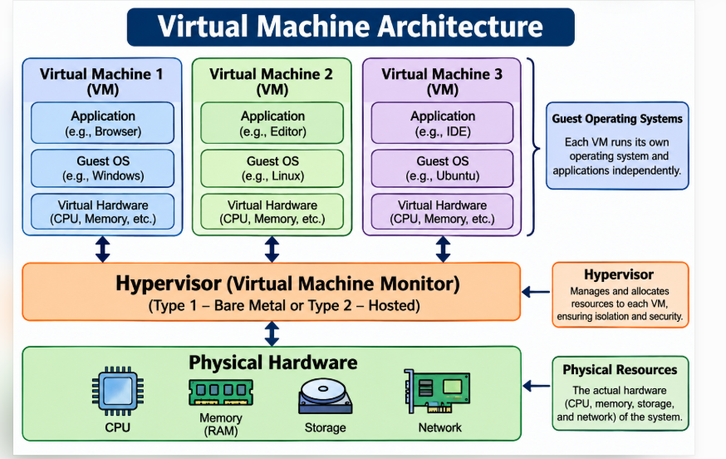

4.2 Container Architecture
A container packages an application together with its libraries and dependencies into an isolated unit. Containers share the host operating-system kernel but have separate process, filesystem and network namespaces. Docker is widely used to build and run containers.

4.3 VM and Container Comparison
Feature | Virtual Machine | Container
Isolation | Separate guest OS and virtual hardware; generally stronger OS-level isolation. | Shares the host kernel; isolation relies on processes and namespaces.
Operating system | Each VM can run its own guest OS. | Must use a compatible host kernel family.
Startup time | Usually slower, because a full OS must boot. | Usually seconds or less.
Resource overhead | Higher, because of the guest OS and virtual hardware. | Lower, because the host OS kernel is shared.
Portability | VM images are portable between compatible hypervisors. | Container images are portable between compatible container runtimes.
Management | Managed through the hypervisor and VM management tools. | Managed through the container runtime and orchestration tools.
Best use | Legacy applications, databases needing OS-level control and applications with different OS requirements. | Stateless web services, APIs, microservices and repeatable deployments.

4.4 University Workload Mapping
University workload | Recommended platform | Reason
Legacy Student Information System | VM | May require a specific operating system, libraries or older software versions.
Student database | VM | Needs controlled storage, memory, backup and database administration; it can be containerized only after validation.
Institutional web portal | Container | The web application can be packaged and replicated easily.
Digital Learning Platform services | Containers | Independent services can be scaled separately using orchestration.
Analytics and report-generation service | Containers or VM | Containers suit repeatable batch services; a VM is appropriate if special OS or hardware dependencies exist.
Examination application | VM or dedicated isolated container group | Requires strict security, controlled access and predictable resources.

4.5 Docker and Kubernetes
Docker builds an image containing an application and its dependencies and runs that image as a container.
A container registry stores versioned images so that deployments can be repeated consistently.
Kubernetes orchestrates containers across multiple hosts. It provides scheduling, service discovery, health checks, automatic restart of failed containers, rolling updates and horizontal scaling.
The Horizontal Pod Autoscaler increases or decreases the number of application pods according to measured resource demand.

4.6 When a VM Is More Appropriate
When the application needs a different guest operating system or kernel.
When a legacy application depends on OS-specific drivers or configuration.
When stronger isolation boundaries are needed between sensitive workloads.
When the application needs direct control over OS patching, kernel settings or specialized software.
Conclusion: The university should use VMs as the secure base for legacy systems and databases, and containers for modern web applications, APIs and independently scalable services. Kubernetes can manage container deployment and scaling.

TASK 5 – DESIGN VIRTUALIZED STORAGE AND NETWORK INFRASTRUCTURE (4 MARKS)

5.1 Storage Virtualization
Storage virtualization combines physical storage devices from multiple systems into a logical storage pool. Administrators can allocate virtual disks to VMs without tying each VM to a single physical disk.
Storage type | Description | University use
DAS | Direct-Attached Storage is connected directly to one server. | Local boot disks or temporary high-speed storage; less suitable for shared failover.
NAS | Network-Attached Storage provides file-level storage over a network. | Shared documents, user files and departmental file shares.
SAN | Storage Area Network provides block-level storage to servers over a dedicated high-speed network. | Shared VM datastores and critical databases that require high performance and multipath access.

5.2 Important Storage Technologies
Software-Defined Storage (SDS): Storage capacity is pooled and managed through software policies rather than being tied to a single storage appliance.
Thin provisioning: Logical storage is allocated to a VM on demand instead of reserving its entire maximum size in advance. Actual free capacity must be monitored.
Snapshots: Point-in-time records of a VM or volume that support short-term rollback. A snapshot is not a replacement for an independent backup.
Replication: Copies data to another storage system or site to support recovery after a failure.
Backup: Creates independent recoverable copies of data, preferably with offline or immutable protection and periodic restore tests.

5.3 Network Virtualization
Network virtualization creates logical networks on top of physical switches and links. A virtual switch connects VMs and containers. VLANs separate traffic at Layer 2, while virtual networks and software-defined networking (SDN) allow network policies to be managed centrally.
Network segment | Purpose and access rule
Administration VLAN | Restricted to authorized IT administrators using MFA and secure management protocols.
Student services VLAN | Provides access to SIS, LMS and public student-facing portals; students cannot reach database management ports directly.
Database VLAN | Allows only approved application servers to reach database ports; blocks direct student access.
Management VLAN | Carries hypervisor, storage and monitoring traffic; isolated from public user networks.
Backup/replication network | Carries encrypted backup and replication traffic over restricted routes.

5.4 Recommended Design
- Use a shared SAN or a reliable SDS cluster for VM disks and critical databases, with redundant controllers and multipath connectivity.
- Use NAS for shared documents, departmental files and user content.
- Use SSD-backed storage tiers for databases and high-I/O services, and lower-cost capacity tiers for archives and backups.
- Use redundant physical switches, virtual switches, VLAN segmentation and firewall rules between security zones.
- Encrypt data in transit and at rest, restrict management interfaces, and monitor storage capacity and network latency.

Conclusion:
SAN/SDS for critical VM storage combined with NAS for file sharing provides flexibility. Segmented virtual networks protect sensitive databases and management traffic.

TASK 6 – PLAN RESOURCE ALLOCATION, SCHEDULING AND MONITORING

6.1 Resource Allocation
CPU allocation assigns virtual processors to VMs and CPU requests and limits to containers. Memory allocation defines the amount of RAM available to a workload. Storage allocation provides virtual disks, volumes and IOPS capacity. Network allocation controls bandwidth, virtual interfaces and traffic policies.

6.2 Static and Dynamic Allocation
Method | Meaning | Advantages / limitations
Static allocation | Fixed CPU, memory or storage assigned in advance. | Predictable, but may waste resources during low demand.
Dynamic allocation | Resources are adjusted according to demand and policies. | Improves utilization and responsiveness; requires monitoring and safe limits.
Reservation | Minimum resource capacity guaranteed to a VM. | Protects critical services during contention.
Limit | Maximum resource usage permitted. | Prevents one workload from consuming all available resources.
Shares | Relative priority when resources are contended. | Useful for prioritizing examination and student services.

6.3 Scheduling and Scaling
Load balancing distributes incoming requests across multiple healthy application instances.
Workload scheduling selects a suitable host or cluster node based on available CPU, memory, affinity rules and policy.
Auto-scaling increases or decreases the number of VM instances, container replicas or cloud resources according to workload metrics.
High availability (HA) restarts or moves workloads after a host or component failure, provided that spare capacity is available.

6.4 Resource Allocation Policy
Workload | CPU policy | Memory policy | Priority
SIS and examination portal | Reserve capacity; moderate limit; high shares. | Guaranteed baseline; avoid swapping. | Critical
LMS and digital learning | Dynamic scaling with a minimum number of replicas. | Requests and limits defined for each service. | High
Library system | Normal shares; scale during peak usage. | Baseline allocation with monitoring. | Medium
Analytics jobs | Schedule off-peak; apply CPU limits. | Limit batch memory use. | Normal
Development/testing | Low shares and strict limits. | Small fixed limits. | Low

6.5 Monitoring Plan and Thresholds
Indicator | Warning threshold (example) | Corrective action
CPU utilization | Above 75% for 10 minutes; critical above 90%. | Identify top consumers, rebalance VMs, scale out or add hosts.
Memory utilization | Above 80% sustained; critical above 90%. | Check for memory leaks, ballooning and swapping; increase memory or replicas.
Disk capacity | Above 80% used; critical above 90%. | Expand the datastore, archive old data and enforce retention.
Disk I/O latency | Above 20 ms sustained on a critical datastore (tune to the workload). | Check queue depth, noisy neighbours and storage health.
Network throughput | Above 75% link capacity sustained. | Inspect traffic, apply QoS or increase link capacity.
Application latency | Above the agreed service objective, e.g. 2 seconds for common portal requests. | Check the application, database, network and load balancer.
VM/service availability | Any failed health check or repeated restart. | Alert the administrator; fail over or restart the service and investigate.

Monitoring tools may include the hypervisor management console, Prometheus and Grafana for metrics, centralized syslog for logs, and application health checks. Alerts should reach the IT operations team by email or through an incident-management system.

6.6 Response to Resource Contention
Confirm the alert and identify the affected host, VM, container or application.
Check CPU ready time, memory pressure, disk latency, network drops and application logs.
Prioritize critical services using reservations and shares, and limit non-critical batch jobs.
Move workloads, add replicas or provision additional capacity if required.
Record the incident and review capacity trends to prevent recurrence.
Conclusion: A combination of reservations, limits, shares, load balancing and auto-scaling helps the university use resources efficiently while protecting critical applications.

TASK 7 – EVALUATE DATA CENTRE AVAILABILITY, SECURITY AND DISASTER RECOVERY (3 MARKS)

7.1 Security Risks and Controls
Risk | Explanation | Mitigation
Hypervisor attack | An attacker targets the virtualization layer. | Patch hypervisors, restrict management access and apply secure configuration.
VM escape | A compromised VM attempts to access the host or other VMs. | Use supported hypervisors, apply patches regularly and enforce strong isolation.
VM-to-VM attack | A compromised VM attacks other VMs on a shared network. | Use VLANs, micro-segmentation and firewall rules.
Insecure snapshots | Snapshots may contain sensitive data or credentials. | Encrypt snapshots, restrict access and delete them according to policy.
VM sprawl | Unused VMs consume capacity and may remain unpatched. | Maintain an inventory, require owner approval, set expiry dates and audit periodically.
Denial of Service | Excessive traffic or resource consumption makes services unavailable. | Apply rate limits, DDoS protection, quotas and load balancing.

7.2 Security Practices
- Use multi-factor authentication (MFA) for administrators.
- Apply role-based access control (RBAC) and least-privilege permissions.
- Encrypt sensitive data at rest and in transit.
- Use secure, patched VM templates and scan container images before deployment.
- Maintain audit logs of administrator actions, VM changes and access to sensitive records.
- Separate the management, student, database and backup networks.

7.3 Backup and Disaster Recovery
A snapshot captures the state of a VM or volume at a point in time and is useful for short-term rollback. A backup is an independent recoverable copy. Replication copies data to another system or site. Live migration moves a running VM between compatible hosts with minimal interruption; it is intended for maintenance and load balancing and is not a substitute for backup or disaster recovery.
Recovery Time Objective (RTO) is the maximum acceptable time to restore a service after a disruption. Recovery Point Objective (RPO) is the maximum acceptable amount of data loss, measured in time.

Application | Proposed RTO | Proposed RPO | Reason
Student Information System | 2 hours | 15 minutes | Student registration and academic records are critical.
Learning Management System | 4 hours | 30 minutes | Learning access should resume quickly, with limited loss of recent activity.

Disaster-recovery plan: Maintain encrypted daily backups and frequent transaction-log backups for databases; replicate critical data to a secondary site or cloud region; keep immutable or offline backup copies; document the recovery order and contact details; test restoration at least twice a year; and record the actual RTO and RPO achieved.
Conclusion: Security requires layered controls across hypervisors, VMs, networks, identities and data. Tested backups, replication and recovery procedures reduce the impact of hardware failure, cyberattacks and site disasters.

TASK 8 – CREATE THE VIRTUALIZED CLOUD DATA CENTRE ARCHITECTURE

8.1 Proposed Architecture Diagram
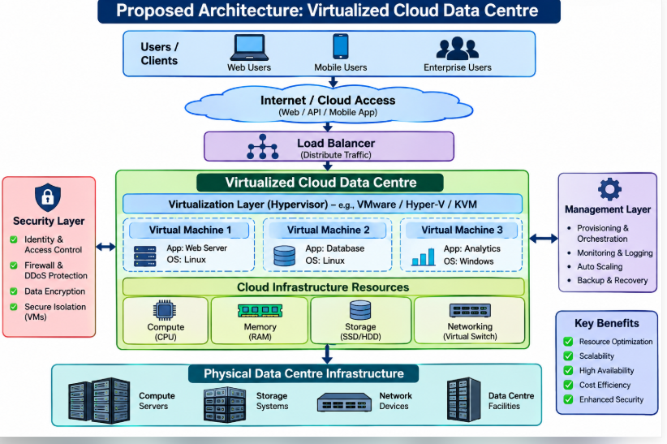.

8.2 Component Explanation
Component | Role and justification
Users and campus network | Students, faculty, administrators and affiliated users access services through controlled entry points.
Firewall and DDoS protection | Filters unauthorized traffic and helps protect public services from malicious traffic.
Load balancer | Distributes requests across healthy web/API instances and improves availability.
Physical hosts and Type-1 hypervisor | Provide pooled CPU and memory; VMs isolate operating systems and critical workloads.
Containers and orchestration | Run modern web applications and APIs; support replica scaling and recovery.
Virtual network / VLAN / SDN | Separates student, administration, database, management and backup traffic.
SAN/SDS and NAS | Provide shared block storage for VM workloads and file storage for documents.
Management plane | Centralizes provisioning, monitoring, logging, identity, configuration and policy enforcement.
Secondary DR site | Stores replicated data and recoverable services to protect against major site failures.

8.3 Deployment and Service Models
Private cloud: The university operates the virtualized infrastructure for institutional workloads that require control and data governance.
Hybrid cloud: Selected services or temporary peak capacity may use a public cloud after security, compliance and cost evaluation.
IaaS: Provides virtual machines, networks and storage for legacy systems and databases.
PaaS: Provides a managed application runtime, databases or deployment platforms for developers.
SaaS: Provides ready-to-use services, such as email, collaboration or learning tools, where appropriate.

8.4 Scaling, Security and Disaster Recovery
Scale vertically by increasing the CPU or memory of a VM where supported, and horizontally by adding web/API replicas behind the load balancer.
Use cluster capacity and live migration to handle maintenance and host failures.
Enforce least privilege, MFA, encryption, image scanning and network segmentation.
Replicate critical databases and maintain independent backups at a secondary site.

Conclusion:
The architecture combines a private virtualized cluster, containers for scalable services, shared storage, segmented virtual networking and a secondary recovery location. It improves manageability, resource sharing and resilience.

TASK 9 – HANDS-ON IMPLEMENTATION AND VALIDATION (4 MARKS)
The following proof of concept uses Docker to run a small university student-record REST API. Execute the commands on a computer with Docker installed. Record your actual configuration and test output; do not claim that screenshots or tests have been completed until you have run them.

9.1 Requirements and Configuration
Software: Python 3, Flask, and Docker Desktop or Docker Engine.
Example resource configuration: 1 CPU and 512 MB memory for the container; adjust these values to the capacity of the computer.
Service: A simple API that returns sample student information.

9.2 Program – app.py
from flask import Flask, jsonify
app = Flask(__name__)
students = [
{"reg_no": "101", "name": "Arun", "department": "CSE"},
{"reg_no": "102", "name": "Meena", "department": "CSE"}
]
@app.route("/")
def home():
return "University Student API is running"
@app.route("/students")
def get_students():
return jsonify(students)
@app.route("/students/<reg_no>")
def get_student(reg_no):
for student in students:
if student["reg_no"] == reg_no:
return jsonify(student)
return jsonify({"error": "Student not found"}), 404
if __name__ == "__main__":
app.run(host="0.0.0.0", port=5000)

9.3 requirements.txt
Flask==3.0.3

9.4 Dockerfile
FROM python:3.11-slim
WORKDIR /app
COPY requirements.txt .
RUN pip install --no-cache-dir -r requirements.txt
COPY app.py .
EXPOSE 5000
CMD ["python", "app.py"]

9.5 Build and Run Commands
Save app.py, requirements.txt and Dockerfile in the same folder. Open a terminal in that folder and run:
docker build -t university-student-api .
docker run -d --name student-api -p 5000:5000 --cpus="1.0" --memory="512m" university-student-api
docker ps
docker stats student-api
Open a browser or use curl:
curl http://localhost:5000/
curl http://localhost:5000/students
curl http://localhost:5000/students/101
curl -i http://localhost:5000/students/999

9.6 Test Cases and Expected Results
Test | Request | Expected result
Home page | GET / | HTTP 200; text: University Student API is running.
Student list | GET /students | HTTP 200; JSON array with two sample students.
Existing student | GET /students/101 | HTTP 200; JSON record for Arun.
Missing student | GET /students/999 | HTTP 404; JSON error message.

The expected results above describe what should happen when the program is run. Insert your actual terminal output and screenshots after execution.

9.7 Validation and Evidence to Capture
- Virtual Machines

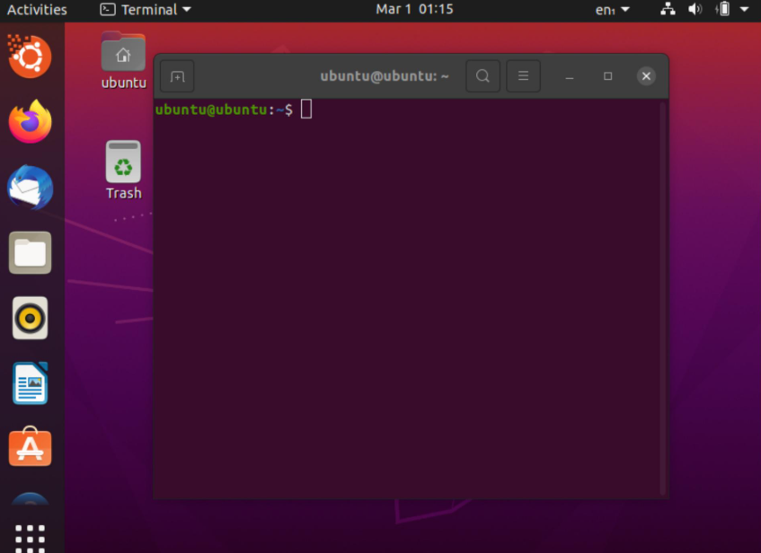

- Docker Installation
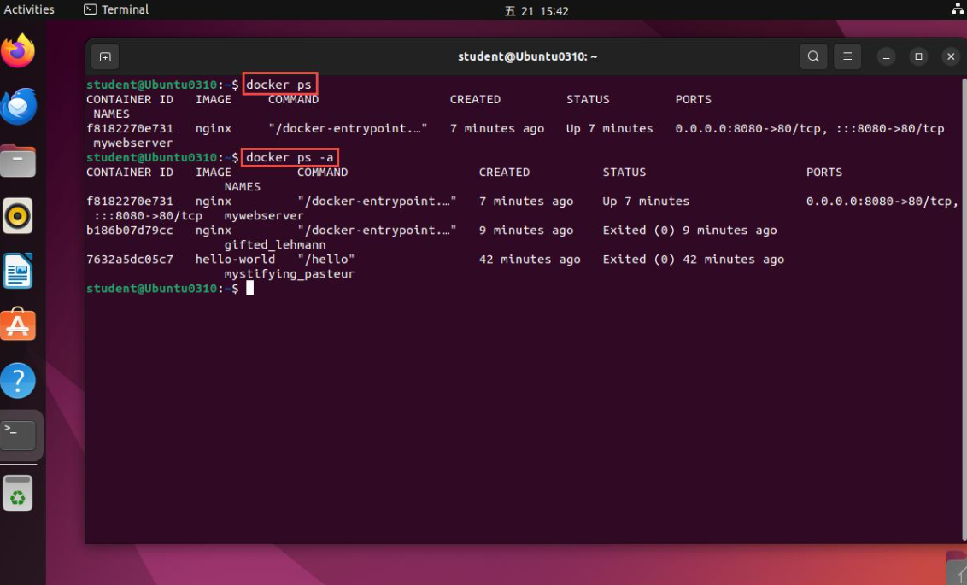

- Running Container and Monitoring

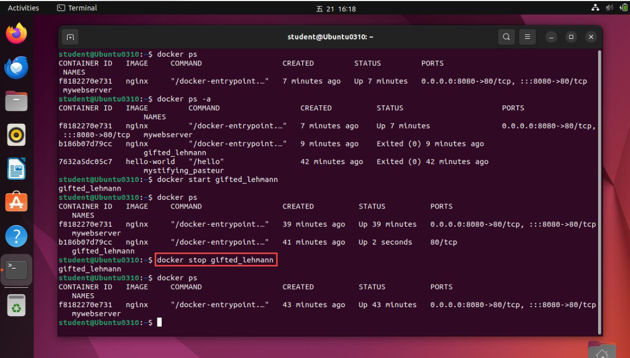

- Resource Configuration and Validation
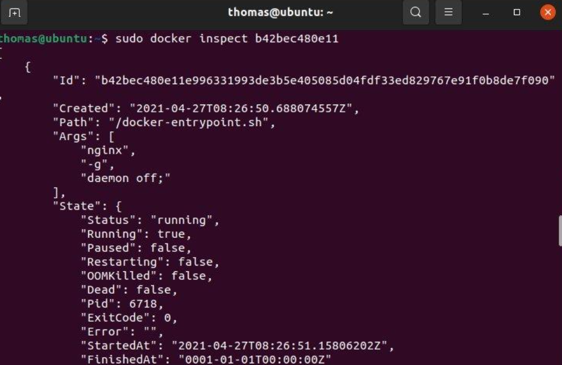

TASK 10 – EVALUATE COST, PERFORMANCE AND FINAL RECOMMENDATION (7 MARKS)

10.1 Cost Assumptions
The following is an illustrative planning estimate in Indian Rupees (INR), not a vendor quotation. Actual costs depend on hardware brands, support contracts, electricity tariffs, software licensing and procurement discounts. The estimate assumes that the existing 20-server environment is replaced by a 16-host virtualized cluster sized for peak capacity, based on the peak calculation in Task 3. Amounts are in lakh rupees (₹ lakh).
Cost item | Existing physical model | Virtualized model
Initial hardware / storage / network CAPEX | ₹80 lakh | ₹100 lakh
Annual electricity and cooling | ₹18 lakh | ₹12 lakh
Annual maintenance and support | ₹10 lakh | ₹8 lakh
Annual licensing and management | ₹4 lakh | ₹8 lakh
Annual administration effort (estimated) | ₹8 lakh | ₹6 lakh

10.2 Three-Year Cost Comparison
Existing model recurring cost per year = 18 + 10 + 4 + 8 = ₹40 lakh
Existing 3-year TCO = CAPEX 80 + (40 × 3) = ₹200 lakh
Virtualized model recurring cost per year = 12 + 8 + 8 + 6 = ₹34 lakh
Virtualized 3-year TCO = CAPEX 100 + (34 × 3) = ₹202 lakh
Cost measure | Existing physical model | Virtualized model
One-time CAPEX | ₹80 lakh | ₹100 lakh
Annual OPEX | ₹40 lakh | ₹34 lakh
Three-year OPEX | ₹120 lakh | ₹102 lakh
Three-year total cost | ₹200 lakh | ₹202 lakh

Interpretation: Under these illustrative assumptions, the virtualized design costs ₹2 lakh more over three years because of its higher initial infrastructure and licensing expenditure. However, its annual operating cost is ₹6 lakh lower. The simple payback period for the additional ₹20 lakh of CAPEX is about 20/6 = 3.33 years, so the financial case becomes stronger over a longer period or if improved utilization, fewer outages and faster deployment create additional savings. A detailed procurement quotation is required before approval.

10.3 Performance and Operational Comparison
Factor | Existing physical model | Proposed virtualized model
Utilization | Average CPU utilization is about 20%. | Pooled resources can be allocated to workloads according to demand.
Scalability | Requires the purchase and installation of another physical server. | VMs and containers can be provisioned faster, and the cluster can be expanded.
Availability | No tested live migration or defined DR site. | Clustering, live migration, replication and a tested DR plan.
Management | Servers are administered separately. | Centralized provisioning, monitoring and policy management.
Power and cooling | More separate servers and associated cooling. | Potential reduction through consolidation, subject to peak capacity.
Deployment | Delays in hardware procurement. | Templates and container images support repeatable deployment.

10.4 Risks and Controls
Risk | Control
Virtualization licensing cost | Compare licensing models, open-source options and support costs before procurement.
Vendor lock-in | Use portable VM formats, standard APIs and container images, and maintain documented exit plans.
Skills gap | Train administrators in hypervisors, networking, storage, containers and security.
Hardware failure | Use N+1 capacity, redundant power and network paths, and spare parts.
Migration downtime | Pilot low-risk systems, schedule maintenance windows, test rollback and verify data.
Performance contention | Use reservations, limits, shares, monitoring and capacity planning.

10.5 Phased Migration Roadmap
Phase | Activities | Reason
Phase 1 – Assessment | Inventory servers, dependencies, utilization, licenses, data and recovery needs. | Avoids migration surprises and identifies suitable workloads.
Phase 2 – Build foundation | Install the hypervisor cluster, shared storage, redundant network, identity management and monitoring. | Creates a secure platform before applications are moved.
Phase 3 – Pilot | Migrate development, test and low-risk web services; validate performance and backup. | Tests the process with limited business risk.
Phase 4 – Core applications | Migrate the library system and institutional website, then SIS and LMS, in planned maintenance windows. | Moves workloads in order of complexity and business criticality.
Phase 5 – Optimize | Tune resource allocations, retire unused servers, and test failover and DR. | Confirms the benefits and improves capacity utilization.

10.6 Final Recommendation
The university should adopt a phased virtualized private-cloud design using a Type-1 hypervisor cluster, shared storage, segmented virtual networking and containers for modern web services. The Task 3 peak calculation indicates that a 16-host, 32-core cluster is needed to support the stated current peak at a 65% planning target with one-host failure reserve. Procurement should be staged and supported by workload measurements. The financial estimate shows that the annual operating savings may take more than three years to recover the higher initial investment; licensing, support and hardware quotations must therefore be compared before final approval.

TASK 11 – DAY-4 DESIGN CHALLENGE: RE-EVALUATE AND ADAPT THE INFRASTRUCTURE (8 MARKS)
Changed requirement: The university introduces a digital learning platform and extends selected services to affiliated colleges. Peak workload increases to five times the current peak. The service must achieve at least 99.9% availability, isolate tenants securely and remain within a limited operating budget. The question paper refers to 10 affiliated colleges in the scenario and to 40 colleges in the later evidence prompts. This design uses 40 tenants for the stricter isolation case; if the final scope is only 10 colleges, the same model applies with fewer tenant configurations.

11.1 Impact Analysis (2 Marks)
- Workload: Digital learning, video and content access, assessments and API traffic raise the peak CPU demand to five times the current peak.

- Users: Students, faculty and administrators from the university and the affiliated colleges access shared services concurrently.

- Storage: Learning content, submissions, attendance and assessment records increase storage and backup requirements.

- Network: More concurrent sessions, file downloads, video traffic and API calls increase bandwidth and load-balancer demand.

- Availability: A single host or site failure must not make the whole platform unavailable; redundant zones and tested recovery are needed.

- Original assumptions affected: The earlier host count, network capacity, storage growth, single-tenant access policies and cost estimate are no longer sufficient without revalidation.

- Web services and APIs become critical because the LMS, student systems, mobile applications and college portals need standardized, controlled communication. An API gateway can authenticate requests, apply rate limits, route traffic and provide logging.

- Multi-tenancy: Each college must have a unique tenant identity and logically separated data, roles, network policies and audit records. Tenant identifiers must be enforced by the application and database access layer rather than simply supplied by the browser.

11.2 Capacity and Availability Evaluation (2 Marks)
Use the current peak CPU demand calculated in Task 3: 304 cores. Assume that the new peak is five times this demand.
New peak CPU demand = 304 × 5 = 1,520 CPU cores
Host capacity = 32 physical cores; target utilization = 65%
Planned CPU demand per host = 32 × 0.65 = 20.8 cores
Hosts without failure reserve = 1,520 / 20.8 = 73.08
Round up = 74 hosts
With one-host failure reserve = 75 hosts
After one host fails: 74 × 32 × 0.65 = 1,539.2 cores
This is greater than 1,520 cores.

Memory estimate: The earlier assumed average memory demand was 768 GB. If peak memory is assumed to be 1.5 times the average and then increases fivefold, the estimated new peak memory is 768 × 1.5 × 5 = 5,760 GB. With 512 GB per host, 75 hosts provide 38,400 GB, or 37,888 GB after one host failure. Memory is therefore not the limiting factor under this simplified assumption. Actual memory use must be measured because workload growth may not scale linearly.

Storage and network: The question does not provide per-user storage or bandwidth figures, so an exact TB or Gbps value cannot be calculated reliably. The university should measure current peak storage growth, IOPS, throughput and concurrent sessions. For initial planning, capacity of at least five times the measured peak workload should be reserved, together with separate backup and replication bandwidth and a storage-growth margin. Object storage or a CDN can be used for large static learning content where suitable.

Availability: 99.9% annual availability allows approximately 0.1% downtime: 365 × 24 × 0.001 = 8.76 hours per year. This target requires redundant hosts, network paths and power, health checks, load balancing, automated recovery, multi-zone deployment, tested backups and clear maintenance procedures.

11.3 Adaptation or Redesign (2 Marks)
Decision: MODIFY the original design into a hybrid, multi-zone, multi-tenant architecture. Retain the Type-1 virtualization foundation and shared-storage principles, but add container orchestration, an API gateway, tenant-aware security, multi-zone deployment and cloud bursting for temporary peaks. A complete redesign is not necessary because the original virtualization base remains useful; however, its capacity and availability design must be expanded.

11.4 Revised Service and Resource Policies
Use IaaS for controlled VM workloads and network foundations; use PaaS or managed database services where they reduce administration and support high availability; use containers and Kubernetes for scalable application services.
Use an API gateway for authentication, throttling, routing, versioning and audit logging.
Use separate namespaces, network policies, quotas and service identities for each tenant. For highly sensitive workloads, consider dedicated databases or dedicated node pools.
Use horizontal auto-scaling for stateless web/API services; scale databases carefully using tested read replicas, connection pooling and caching.
Set per-tenant CPU, memory, storage and request quotas to prevent one college from exhausting shared resources.
Replicate critical data across zones and maintain immutable backups in a separate region.

11.5 Evidence-Based Defence and Trade-offs (2 Marks)
Area | Original design | Modified design
Peak CPU planning | 16 hosts for current 304-core peak with N+1. | Approximately 75 hosts at five times the peak under the same 32-core/65% assumptions, or measured hybrid-cloud burst capacity.
Availability | Single cluster with a secondary backup site. | Multi-zone service deployment, redundant load balancers, automated recovery and secondary-region DR.
Tenant security | Basic VLAN and role separation. | Tenant-aware identity, data partitioning, namespace and network policies, quotas, per-tenant audit and optional dedicated resources.
Cost | Higher initial hardware cost but lower annual OPEX. | Higher variable cloud and managed-service costs during peaks; capacity reservations and auto-scaling limit waste.
Complexity | Conventional VM cluster administration. | More complex orchestration, API gateway, tenant governance and cloud operations.

Cost control strategy: Keep predictable baseline workloads on the university’s private cluster, and use auto-scaling and cloud bursting for short peak periods after performance and security testing. Apply budgets, quotas, tagging and cost alerts for each college. Compare reserved capacity with on-demand pricing, and avoid running peak capacity continuously when demand is seasonal.
Trade-offs: Multi-zone deployment improves resilience but increases infrastructure and network costs. Managed PaaS reduces operational effort but may increase vendor lock-in. Kubernetes supports scale and portability but requires trained administrators. Strong tenant isolation improves security but can reduce resource-sharing efficiency. The university should balance these factors using measured load tests and a pilot with selected colleges.
Final decision: Modify the original design. Retain virtualization for the stable baseline, add container orchestration and API management for elastic digital learning services, and use multi-zone or hybrid-cloud capacity to handle the five-times peak. The calculated figure of 75 hosts is a theoretical all-on-premises peak plan; a hybrid approach can reduce capital expenditure if burst capacity is contractually available and tested. The 99.9% target must be verified through monitoring and failover exercises, not assumed from the architecture alone.

REFERENCES
1. CSA15 – Cloud Computing and Big Data Analytics, Assignment 1 – CO1, question paper supplied by the faculty.
2. NIST, The NIST Definition of Cloud Computing, Special Publication 800-145.
3. Docker Documentation, https://docs.docker.com/
4. Kubernetes Documentation, https://kubernetes.io/docs/
5. VMware vSphere Documentation, https://docs.vmware.com/
6. Microsoft Learn – Hyper-V virtualization documentation, https://learn.microsoft.com/
7. Prometheus Documentation, https://prometheus.io/docs/
8. OWASP, Application Security Verification Standard and API Security guidance, https://owasp.org/

